Kaila Sanford
EDUC 5180
Professor Wasserman
3/23/15
Classroom Observation Essay 1
During this semester I have been observing primarily at Coleman Elementary School. I have also done lesson studies at Mark Day School and Dixie Elementary. Some of the most impressive things that I have seen and would like to carry on into my teaching practice have been: a socio-emotional curriculum, fantastically smooth transitions, reading partnerships that worked flawlessly and fun strategies for making math assessments less stressful. I have been impressed and inspired by the teachers who have let me observe in their classrooms, and for that I am very grateful.
The most interesting thing that I hope to incorporate into my future teaching is something that I saw at a private school while doing a lesson study for my Teaching Reading class. My classmates and I watched a 50-minute English language arts lesson in a first grade classroom at Mark Day School. The teacher, Geneva Conway, is a veteran teacher and has been at Mark Day School for many years.
The lesson we saw involved students rotating through several centers throughout the classroom, each with a different language arts activity. I will talk more about the details of this lesson later. While observing a transition into a guided reading group, several of my peers noticed that the students did a distinct movement with their hands after sitting down but before beginning their activity. It was so subtle that I didn’t even notice it happen as I was taking notes.
Later, in the post-observation discussion, one of my peers mentioned this hand movement, and Ms. Conway pointed out one of the many posters on her classroom’s wall. It is a poster representing the students’ emotional toolbox—the tools they have learned to regulate emotions and solve problems on their own. See photo below:

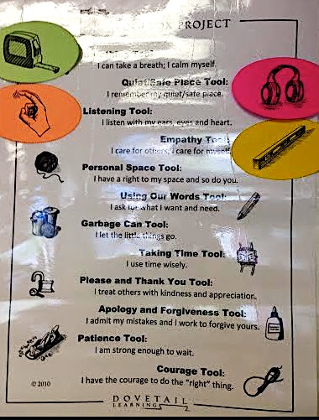

This poster is part of a curriculum called the Toolbox Project, which is a resource created by the company Dovetail Learning. While I haven’t done substantial research into the full curriculum surrounding the poster, I can envision using this poster and its strategies in all of my future classrooms. I absolutely love the idea of teaching kids that they have inside them the tools needed to solve problems that may arise in their lives. This poster contains in it strategies that empower the students and teaches them valuable life skills that they’ll be able to use every day for the rest of their lives! How many posters can do that?
I recognize that, as a private school, Mark Day has the resources to have a separate teacher who teaches social and emotional wellness classes. I probably won’t have a separate class period to teach these valuable skills, so I will have to incorporate them into my daily teaching as much as possible. With my background in psychology, I know how important emotional regulation is and how empowered children feel when they know how to deal with tricky situations. I feel confident in my ability to introduce life skills like these alongside regular schoolwork and have my students really believe in what they are doing.
Another thing that I really admired in Ms. Conway’s class was how well her students managed their transitions between activities in their language arts centers. Ms. Conway had taught the routines for transitions so well that her students didn’t need to be told where to go or what to do for each activity. These first graders needed only a reminder at the beginning of the class period to look at the chart on the board, see where they needed to go, and calmly proceed to that location. They happily, and in an organized manner, did exactly that. There was some low-level chatter during the transitions, but it was as smooth as I could ever imagine. Here is a photo showing the students’ names and agenda for their activities during that class period:
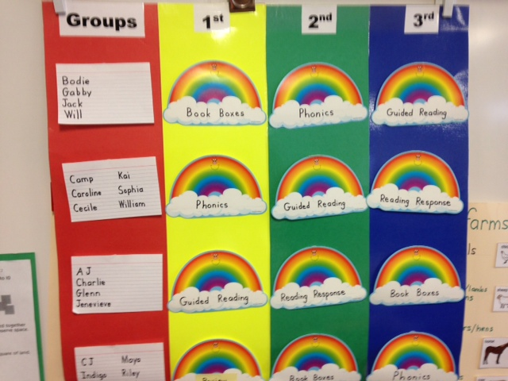
For this class period, students had been divided into 4 groups according to their reading and comprehension scores. These groups moved through three stations during the class period. I was really impressed, not only at the high level of work that these students were producing, but with how engaged they were with the material. Because the students felt secure and had absolutely no questions about how they were supposed to conduct each activity, they were engaging with the material at a much deeper level than they would have been if the activity centers were unfamiliar.
As a new teacher, I see transitions between activities as somewhat frightening times where a lot of time could potentially get wasted with students asking procedural questions and interpersonal conflicts arising. Ms. Conway’s class demonstrated that even 6 and 7 year-olds can be efficient in transitions if they know what they are doing, where they are going, and how they are supposed to behave. Seeing this in action really brought home the lesson that I’ve been reading about; that taking time early in the year to establish routines really saves time throughout the rest of the year.
Another language arts lesson that I was lucky enough to observe took place at Coleman Elementary, in Ms. Thomas’ 3rd grade class. I knew before attending this class that Ms. Thomas was formerly a reading interventionist, so I knew I was in for a treat seeing her language arts class. What I didn’t expect to see is what delighted me: the kids were helping and teaching each other!
Ms. Thomas uses a reading curriculum called PALS, which stands for Peer Assisted Learning Strategies. This curriculum was developed by researchers at Vanderbilt University and is aligned with the Common Core State Standards. During the lesson I observed, students were matched in heterogeneous pairs, with one student being a high-level reader and their partner being a lower-level reader. No scores were actually discussed with the students. The students understood that they were taking turns helping each other and one of them happened to need a little more help than the other. In their pairs, the students took turns being the coach and the reader. As the reader reads aloud, the coach listens and provides helpful feedback according to pre-written sentence starters that encourage positivity and helpfulness.
What I appreciated about this activity was how respectful the students were being with one another. They never interrupted each other and were really helping each other with fluency and comprehension. The students had chosen the books from which they were reading, so they were interested in the material and really wanted to keep the reading going. Ms. Thomas had taught this activity so well that she had time while the students were reading to each other to look at assessments and focus on the students who needed the most help. The classroom noise level was low, but energetic, with about 12 voices reading aloud quietly at any given time.
I am not used to seeing peers help each other so directly and for a sustained period of time. I really enjoyed seeing how well the students treated each other and how they seemed to appreciate the activity. I am not sure if I will use the PALS curriculum in my classroom, but what I gained from this observation was a sense of how students enjoy helping each other. Peer support is a valuable resource that isn’t often utilized until middle or high school. Ms. Thomas is teaching her 3rd grade students that they can help and support each other with academics. I hope that I can teach my students the same and that they can begin tapping that valuable resource before they get to high school.
One last thing I’d like to mention is the fun activity I observed in another 3rd grade classroom at Coleman Elementary. Mrs. Kenney used an informal way to help her students expand their mental math abilities. 3rd grade involves a lot of multiplication, which could possibly get boring and repetitive. Mrs. Kenney used a ball-tossing activity to reinforce the lesson that, when multiplying by tens and hundreds, you can add the appropriate amount of zeroes to the math facts that you already know. I could see from the board that she had taught a formal lesson on this before I stepped into the classroom and that what I was seeing was a way that she could assess the students’ understanding of the lesson.
Mrs. Kenney started by asking her class to raise their hands if they knew the answer to 3x5. Most of the class raised their hands. She said the name of one student and tossed him a soft ball. He caught the ball, gave the answer, received an affirmation from the teacher, and tossed the ball back. Mrs. Kenney then asked the class to raise their hands if they knew the answer to 30x5. Again, a name was called, the ball was passed, the student gave a correct answer, and the ball was passed back. The same thing happened for 300x5. Then another question was introduced and the same procedure occurred with the answer being increased by 10 and 100.
Because Mrs. Kenney provided ample wait-time and the ball-tossing begins with students raising their hands, the fear of being called on and being put on the spot is reduced greatly. There was one instance when a student did answer incorrectly. The whole class was respectful and supportive of this student. In this procedure, if a wrong answer is given, the student keeps the ball until they get the right answer. In this case, the student had done the basic multiplication fact incorrectly. Mrs. Kenney said “not quite, check your multiplication facts,” gave wait time, and the student eventually answered correctly. None of the other students laughed or commented.
There were several things that I liked about this activity and that I could use in my future teaching practice: the students felt safe and respected, mental math was encouraged and supported, and the teacher was right in there doing the math with the students. Something that especially stuck out to me in this lesson was the timing. Mrs. Kenney is an experienced teacher, and she gave just the right amount of time for the students to think about the question and raise their hands before calling on anyone. I could tell that she was also doing the problem in her head, and then maybe counting to 5 in her head before asking the students to reply. Conversely, this activity was used as a quick assessment and didn’t drag on or become tedious. She knew just the right amount of questions to ask before the activity became disinteresting. I suppose that kind of timing comes with practice. I look forward to recreating something similar that grabs the students’ attention, provides me with helpful feedback about student understanding, and gives the students mental math practice.
There are so many little instances like this last one that have stuck with me through my hours of observations. I have seen that teaching moments can happen through large-scale units as well as through little games that happen in between formal activities. I have seen great examples of time management, clear expectations, safe spaces, and positive learning environments.

Yes, the thing I see as the most important moment I’ve observed so far in my teaching program is something I didn’t even notice! Can you believe it?

